Lyng Primary School Knowledge Organiser
Topic: | Anglo-Saxons  Why did the Anglo-Saxons choose to settle in Britain? | Year 4  Battles, beliefs and buildings | Autumn

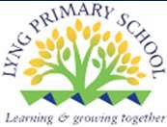
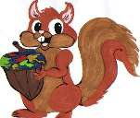
?
W
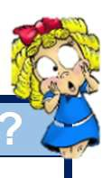
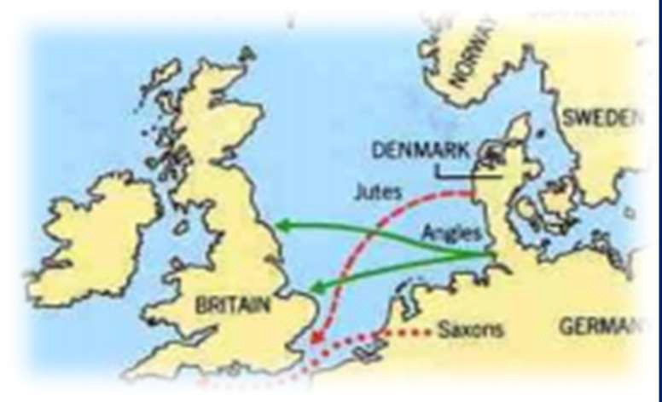

Let’s recap…

To discover more:

National Geographical Kids - https://www.natgeokids.com/uk/discover/history/general-history/anglo-saxons/

BBC Bitesize - Anglo-Saxons https://www.bbc.co.uk/bitesize/topics/zxsbcdm

Britannica Kids – Anglo-Saxons https://kids.britannica.com/kids/article/Anglo-Saxon/352755
What Step On and Goldilocks words will I use?
Spelling | Definition
Settlements | A settlement is a place where people have come to live and have built homes.
County | A county is a region of Britain, Ireland, or the USA which has its own local government.
Region | A region is a large area of land that is different from other areas of land
Invaders | Invaders are soldiers who are invading a country.
Invasion | If there is an invasion of a country, a foreign army enters it by force.
Etymology | Etymology is the study of  the origins and historical development of words.
Legacy | A legacy of an event or period of history is something which is a direct result of it and which continues to exist after it is over.
Location | A location is the place where something happens or is situated.
Tribe | The three tribes called Angles, Saxons and Jutes.
Rural | Characteristic of a countryside.
Agricultural land | Land devoted to growing crops and farming practices.


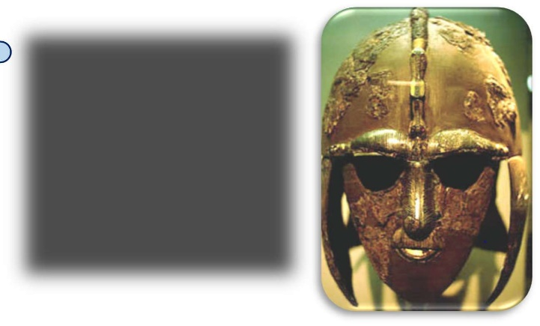
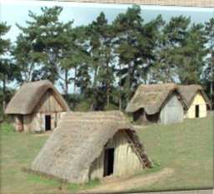
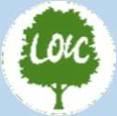
Fieldwork Opportunities
- Anglo-Saxon man.

Significant places
- Mercia
- East Anglia
- Northumbria
- Kent
- Sussex
- Essex
- Wessex
- Norway
- Denmark
- Sweden
- Scandinavia
Our overarching question is: Why did the Anglo-Saxons choose to settle in Britain?
- Why did the Anglo-Saxons invade Britain?
- Where in Britain did the Anglo-Saxons invade?
- What names did the Anglo-Saxons name places?
- Were Anglo-Saxon houses purposeful?
- How were Anglo-Saxon settles different to others? (Comparison lesson)
Enquiry Questions
Year 1 – Children begin to understand what the world looks like (identify continents – Europe).
Year 2 – Children learn the names of the seas and oceans connecting UK to Europe.
Year 3 – Children learn about biomes in Europe (tundra) which will link to learning about settlement choices.

Our Storytelling Approach to enhance engagement

People:  Magnus (Anglo-Saxon Boy) | Place:  Northumbria | Problem:  He discovers his uncle has changed and must report back to his father.
Key facts and locations
Map to be studied


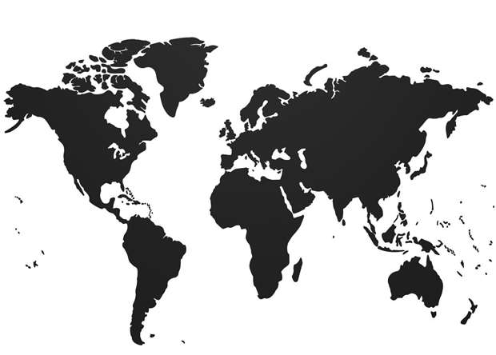

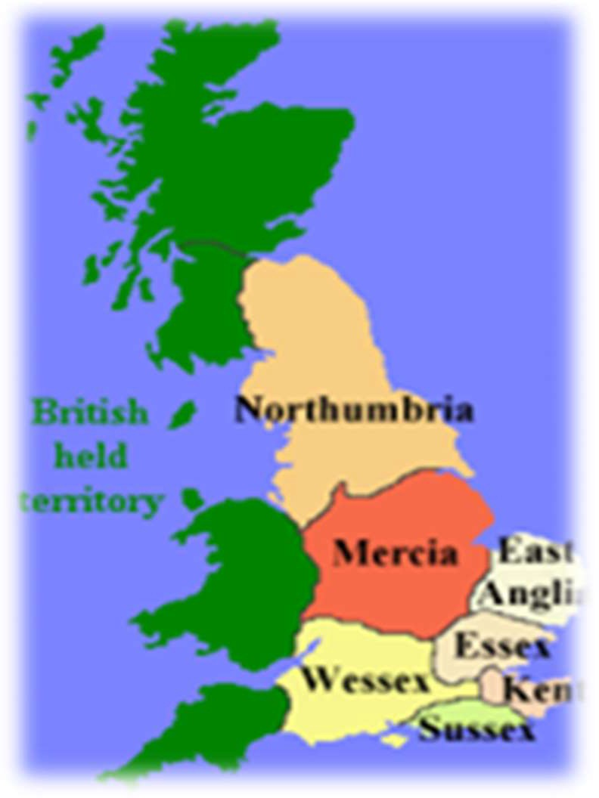
The Anglo-Saxons came to England after the Romans left in the year 410. Nobody was really ruling all of England at the time – there were a lot of little kingdoms ruled by Anglo-Saxons that eventually came together as one country.

The Anglo-Saxons are made up of three tribes who came to England from across the North Sea around the middle of the 5th century – the Angles, Saxons and Jutes.

Some of our modern English words are from the Anglo-Saxons, such as the days of the week, we can see this in see this in place names throughout England.

Anglo-Saxons lived in small villages near rivers, forests and other important resources that gave them everything they needed to care for farm animals, grow crops and make things to sell.

We know how the Anglo Saxons lived because archaeologists have found old settlements and excavated artefacts like belt buckles, swords, bowls and even children’s toys.

Sutton Hoo is near the town of Woodbridge in Suffolk, England. The site was excavated in the 1930s and it has
revealed some incredibly important finds and helped to further our knowledge of the Anglo-Saxons in Britain.
The items discovered at Sutton Hoo almost certainly date from the 7th century. One of the items discovered in a burial chamber was an entire ship and its contents. The ship almost certainly belonged to an important

Agreed Outcome
A labelled map of the UK with Anglo-Saxon towns and counties.
warrior or leader and it was hauled up the River Deben to the burial site.

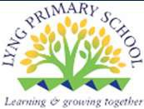
Lyng Primary School Knowledge Organiser
Topic: | Anglo-Saxons  Why did the Anglo-Saxons choose to settle in Britain? | Year 4  Battles, Beliefs and Buildings | Autumn

1. Which continent did the Anglo-Saxon tribes come from? | S | E
a) Africa
b) Asia
c) Europe

5. What Anglo-Saxon Kingdom is Birmingham located within? | S | E
a) Mercia
b) Kent
c) Essex

2. What was the Midlands called during the Anglo-Saxon era? | S | E

6. What does ‘Essex’ mean? | S | E
a) East England
b) East Midlands
c) East Saxons

3. ‘Ham’ means village. True or false? | S | E

7. What geographical location did Anglo-Saxons choose to live by? | S | E

4. What is a settlement? | S | E
a) A place where people live.
b) A castle on a hill.
c) A tent in a field.

8. What were Anglo-Saxon roofs made from? | S | E
a) Hay
b) Brick
c) Tiles

